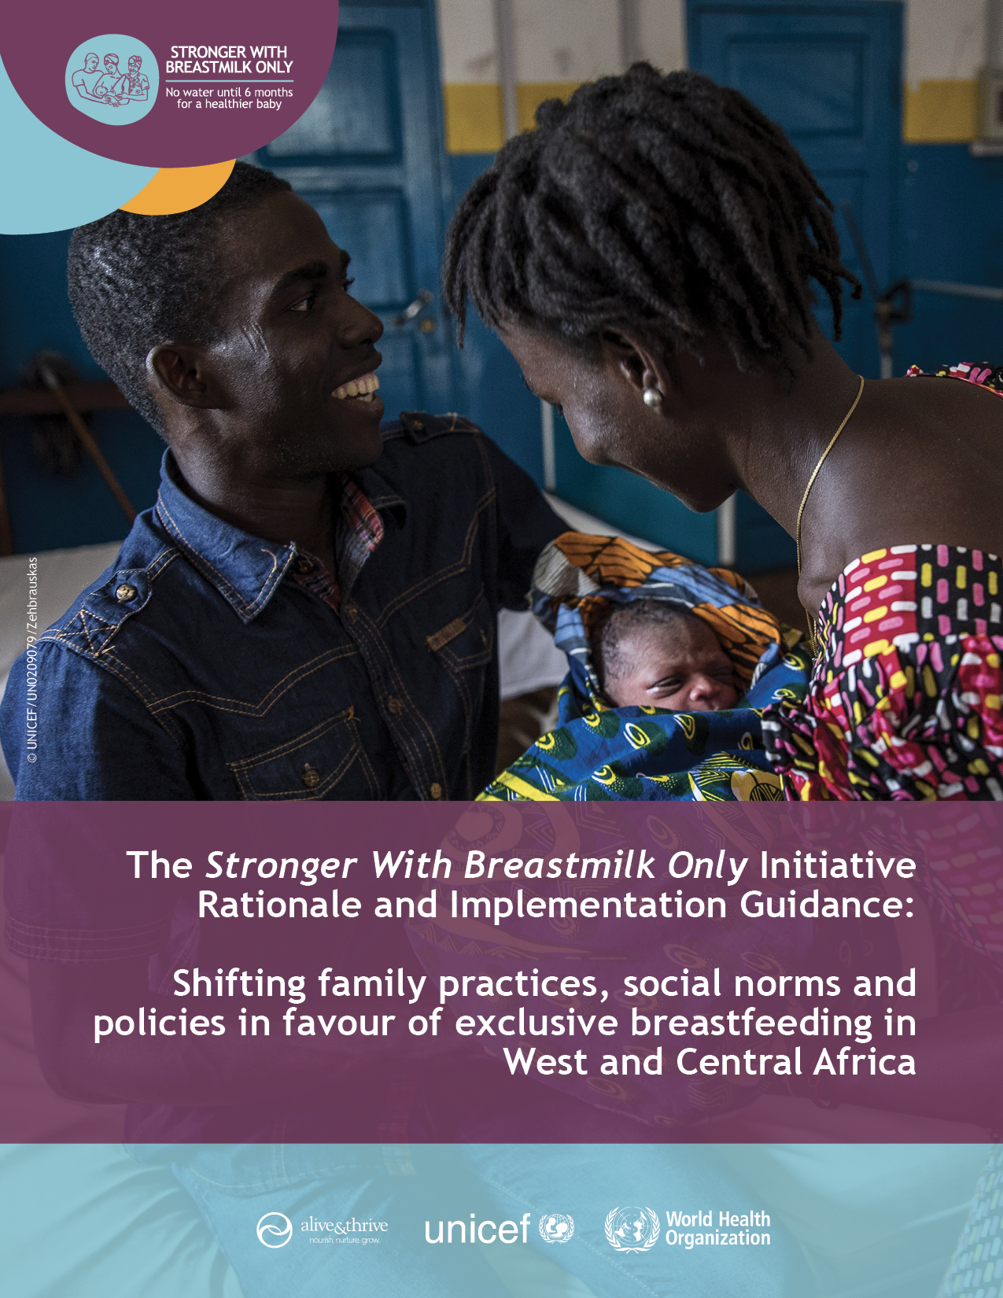

Table of contents

Preamble 3
What is the purpose of this document? 3
How was this document developed? 3
Who is the intended audience? 3
I. Introduction 4
I.1. Stronger With Breastmilk Only background 4
I.2. The benefits of exclusive breastfeeding 5
II. Context 7
II.1. Patterns in exclusive breastfeeding in West and Central Africa 7
II.2. Factors influencing exclusive breastfeeding in West and Central Africa 10
II.3. Framework of change 11
II.4. Social ecological model 13
Table 1: People of influence and their roles in breastfeeding decision-making by social ecological level 14
III. Regional objectives 16
III.1. Stronger With Breastmilk Only main objectives 16
III.2. Stronger With Breastmilk Only specific objectives 16
Tables 2-7. Desired behaviours and SBC objectives by type of ‘change agent’ based on SBC determinants 16
IV. Approaches and activities, and specific guidance for communication and advocacy 23
IV.1. Lessons learned 23
Table 8: Level of influence (left side) and corresponding SBC approaches, activities and channels (right side) 23
IV.2. Communication guidance 26
Table 9. Some key facilitators and barriers to consider in communication 28
IV.3. Advocacy guidance 30
Table 10. ‘Problem – solution – impact – call to action’ model for ‘breastmilk only, no water’ advocacy 31
V. Monitoring and documenting Stronger With Breastmilk Only 33
V.1. Stronger With Breastmilk Only results tracker 33
Table 11. Stronger With Breastmilk Only results tracker: indicator names and descriptions 34
V.2. Documenting Stronger With Breastmilk Only 36

Preamble

What is the purpose of this document?
This document gives implementation guidance and tools for countries to design, implement and monitor a national Stronger With Breastmilk Only initiative in their unique context.

How was this document developed?
It was crafted based on the global and regional evidence of effectiveness of breastfeeding programmes, the situation analysis and regional literature review of determinants of infant feeding practices, and drawing on global best practices for social and behaviour change interventions.

Who is the intended audience?
It is intended for professionals responsible for leading, coordinating and participating in the design, implementation and monitoring of the Stronger With Breastmilk Only initiative in their countries. They may be representatives from governments, United Nations (UN) organizations, non-governmental organizations (NGOs), academic institutions, advocacy networks, professional associations, private businesses, civil society groups, media and community-based organizations.

How should this document be used?
This document provides the background and foundational guidance for implementation of the initiative. Each of the elements are to be adapted at country level, tailored to specific features of the context which will be identified through each country’s own research.

The document suggests regional advocacy and communication products and written and audiovisual resources (identified by the icons below) that can be consulted when adapting the Stronger With Breastmilk Only initiative to national contexts. These resources will be updated on the website as the initiative is implemented.

It is accompanied by a ‘how-to’ guide for developing a tailored SBC strategy: The Stronger With Breastmilk Only Initiative Design Process: Guide for Designing a National Stronger With Breastmilk Only Initiative to Improve Rates of Giving Infants Breastmilk Only in the First Six Months of Life.

Icon | Type of resources
 | Regional advocacy or communication product that can be tailored to the country’s context
 | Written or audiovisual material that can illustrate a concept or serve as an example.

Introduction

I.1. Stronger With Breastmilk Only background

Increasing exclusive breastfeeding rates of infants aged zero to five months is a key strategy to reduce childhood stunting and to improve child survival, health and emotional, intellectual and physical development; all of which are priorities for countries in West and Central Africa.

Exclusive breastfeeding occurs when: an infant receives only breastmilk, with no other liquids or foods given – not even water – with the exception of oral rehydration solution, or drops/syrups of vitamins, minerals or medicines in the first six months of life.

In West and Central Africa, while breastfeeding infants is the norm, exclusive breastfeeding in the first six months of life is less prevalent. Most breastfed infants younger than six months in the region receive other liquids and foods. An analysis of data on breastfeeding practices in the first six months of life across the 24 countries of UNICEF’s West and Central Africa region (Figure 1) identified giving breastfed infants plain water in the first six months of life as the main reason for non-exclusive breastfeeding. According to UNICEF data, 40 per cent of breastfed infants aged zero to five months in the region received plain water. UNICEF estimates that if plain water were no longer given in the first six months of life, all countries in the region would reach the global World Health Assembly (WHA) target of at least 50 per cent by 2025.

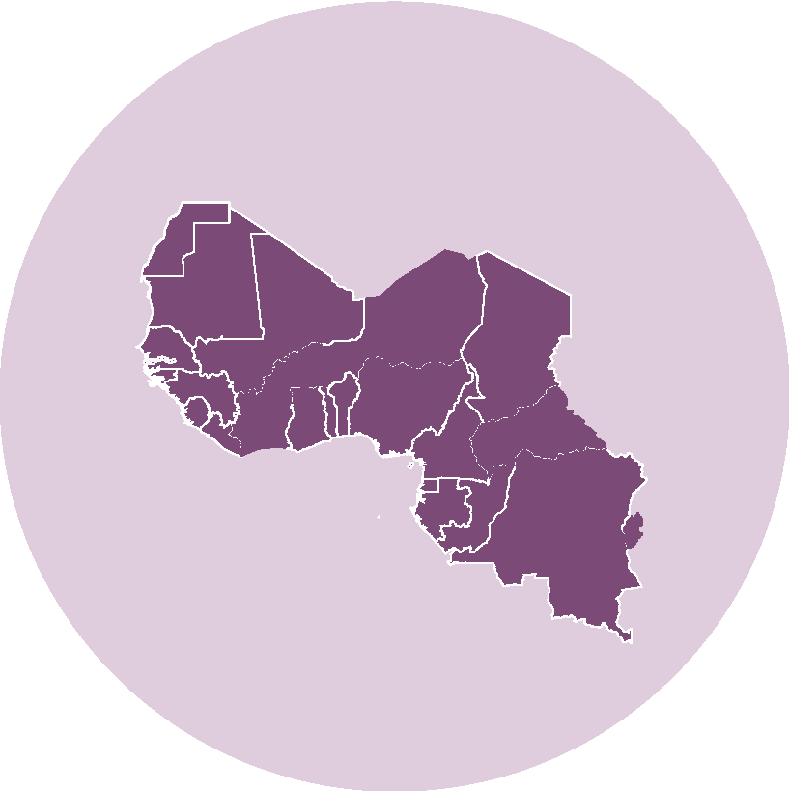
Figure 1: 24 countries covered by the Stronger With Breastmilk Only regional initiative as defined by UNICEF West and Central Africa regional office

Giving water, as well as other liquids and foods, to babies in the first six months of life places them at risk of illnesses and under-nutrition. Germs in unsafe water, other liquids and foods and feeding utensils can cause diarrhoeal and respiratory infections. When breastmilk is replaced by water, the baby does not get the food she needs to grow and the mother’s breastmilk production decreases. In fact, a mother’s body adapts to breastmilk demand: the more a baby breastfeeds, the more breastmilk there is.

In response, UNICEF West and Central Africa, Alive & Thrive and their partners are calling upon countries to scale up breastfeeding interventions by designing and implementing evidence-informed strategic advocacy and communication initiatives for sustainable social and behaviour change (SBC) in favour of exclusive breastfeeding across the region. The Stronger With Breastmilk Only regional initiative intends to build a regional movement and incite national action towards achieving the 2025 WHA global exclusive breastfeeding target. It places the spotlight on the practice of giving water to babies as the key barrier in the region, and as an entry point for the protection, promotion and support of giving breastmilk only for the first six months of life. It also considers other common practices that prevent exclusive breastfeeding.

Giving breastmilk only immediately from birth and for the first six months of life – without giving water, other liquids or foods to the baby - is positioned as a simple, doable and loving action that protects and improves the survival, growth, development and well-being of babies and an action that has long-term positive impacts for babies, mothers and their communities.
The Stronger With Breastmilk Only regional initiative specifically calls for:
- Increased attention and funding at regional and national levels to protect, promote and support recommended breastfeeding, including giving infants breastmilk only, no water, other liquids or foods in the first six months of life.
- The design, implementation and monitoring of national evidence-informed strategic advocacy and SBC strategies to promote giving infants breastmilk only from the moment of birth and in the first six months of life.
- Regional and national partnership-building across multiple sectors and types of organizations (government, non-governmental, business, academia, professional bodies, civil society and the media) to rapidly achieve programmatic scale and sustainability.

Box 1: Is it enough to focus only on stopping the practice of giving water to babies younger than six months?

While the focus on not giving infants younger than six months water is clear, water may not be the only type of supplement that is given.

Countries must tailor the initiative to their specific contexts and realities. This initiative, with its focus on ‘breastmilk only, no water’ is an entry point for dialogue on broader feeding practices that affect the survival, development and well-being of infants in the first six months of life. These practices include (but are not limited to): giving infants plain water, herbal teas and remedies, sugar water, gripe water, milk, formula, and other liquids, and introducing foods, such as porridge before the recommended age of six months.

I.2. The benefits of exclusive breastfeeding

There is well-documented evidence of the benefits of breastfeeding up to 24 months and exclusive breastfeeding initiated within an hour of birth and lasting for the first six months of life (UNICEF, October 2016). Below are some of the benefits of breastfeeding and breastmilk.

For infants and young children:

- Breastfeeding saves lives providing essential, irreplaceable nutrition needed for child survival, growth, health and early development.
- Breastmilk is a complete food for babies, containing all the energy, nutrients, and water a baby needs during the first six months of life.

- Breastmilk is safe and keeps infants safe, even in unsanitary environments, by avoiding contaminants in water and foods.
- Breastmilk is a baby’s ‘first vaccine,’ boosting the immune system with antibodies passed from the mother.
- Breastfeeding promotes emotional development through mother and baby bonding that supports growth and mental development.
- Breastfeeding may reduce risk of obesity and chronic diseases later in life.
- Longer term breastfeeding supports intellectual development.
For women:
- Breastfeeding protects women’s health. Breastfeeding facilitates recovery from childbirth. It reduces a woman’s risk of heart disease, type 2 diabetes and ovarian and breast cancers. When breastfeeding is exclusive, it can delay ovulation acting as a natural family planning method, thus promoting birth spacing.
For nations:
- Breastfeeding contributes to a nation’s prosperity. From a financial point of view, breastfeeding is considered one of the smartest investments a country can make to build its future prosperity. The World Bank Group’s Investment Framework for Nutrition estimated that every dollar invested in supporting breastfeeding generates US$35 in economic returns (Shekar et al, 2017), by avoiding great costs associated with not breastfeeding.

- The estimated gains of implementing breastfeeding programmes in Sub-Saharan Africa are among the highest in the world, with 2.57 per cent of Gross National Income losses prevented through recommended breastfeeding alone. Globally, Alive & Thrive estimates that practicing breastfeeding as recommended by WHO and UNICEF could prevent US$341 billion in economic losses (Walters & Mathisen. 2019).

Consult Alive & Thrive’s interactive ‘Cost of Not Breastfeeding Tool’ to calculate what economic losses can be prevented by implementing programmes that protect, promote and support recommended breastfeeding practices. (https://www.aliveandthrive.org/cost-of-not-breastfeeding/)

‘Cost of Not Breastfeeding’ Briefs have been developed for each of the 24 countries of the West and Central Africa region.
https://www.aliveandthrive.org/resources/the-cost-of-not-breastfeeding-in-west-and-central-africa/

Stronger With Breastmilk Only Fact Sheet: ‘Breastmilk, the Only Source of Water and Food Babies Need for the First Six Month of Life’

Context

II.1. Patterns in exclusive breastfeeding in West and Central Africa

A review of exclusive breastfeeding data in West and Central Africa countries reveals a gap between ideal and actual practices. While breastfeeding young children is nearly universal in the region, being deeply rooted in social norms and family practices, the low exclusive breastfeeding rate highlights the need for a stronger, concerted effort to promote giving breastmilk only during the first six months of life (Figure 2). The following presents crucial data that this strategy is designed to address.
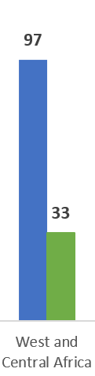

More than half of newborns received breastmilk late, rather than immediately after birth. At 41 per cent, the proportion of West and Central African newborns receiving breastmilk in the first hour of life is amongst the lowest in the world (UNICEF 2019).

For most babies in the first six months of life, breastfeeding is not exclusive; most breastfed infants also receive water, other liquids or foods.

In West and Central Africa, only 33 per cent of infants receive breastmilk only in the first six months of life. Sixty-seven (67) per cent received water, other liquids and foods in addition to breastmilk (Figure 2).
Figure 2: ever breastfeeding rates and exclusive breastfeeding (in per centage) Source: UNICEF global databases, 2019.

In most countries in the region, exclusive breastfeeding rates have improved since the early 2000s (Figure 3). Significant increases of more than 20 percentage points in exclusive breastfeeding rates were observed in Burkina Faso, Cape Verde, DRC, Gambia, Guinea Bissau, Mauritania, Niger, Sierra Leone and Togo. In contrast, rates decreased in Chad and Equatorial Guinea and stagnated in Gabon and Ghana.

The regional exclusive breastfeeding rate of 33 per cent masks extreme disparities between countries (Figure 3). Mothers report that 0.1 per cent of infants were exclusively breastfeed in Chad, in contrast to Sao Tome and Principe where most infants aged zero to five months received breastmilk only (71.7 per cent). Seven of the 24 countries in the West and Central Africa region have exclusive breastfeeding rates above 50 per cent. They include: Burkina Faso (50.1 per cent), Cap Verde (59.6 per cent), Ghana (52.1 per cent), Guinea Bissau (52.5 per cent), Liberia (54.6 per cent), Sao Tome and Principe (71.7 per cent), and Togo (57.2 per cent).
Figure 3: Trends in rates of exclusive breastfeeding by country in West and Central Africa (in per centage) Source: UNICEF global databases, 2019, based on MICS, DHS and other nationally representative sources.
Exclusive breastfeeding rates decrease with infant age (Figure 4). Rates drop rapidly after the first month of life in all countries, but the greatest drop varies between countries.
In 10 countries, the percentage drop is greatest between the first month of life and 2-3 months of age. (Those 10 countries are: Burkina Faso, Central Africa Republic, Congo, Cote d’Ivoire, Gabon, Guinea, Guinea-Bissau, Mali, Mauritania and Senegal). In the remaining 14 countries, the greatest drop takes place between 2-3 months and 4-5 months of age.
Figure 4: Rates of exclusive breastfeeding by age group by country in WCAR (in per centage) Source: UNICEF global databases, 2018, based on MICS, DHS and other nationally representative sources.
The median duration of exclusive breastfeeding is less than three months throughout the region (Figure 5). Even more concerning is that median duration is less than one month in 10 out of 18 countries with available data in the region (Burkina Faso, Cameroon, Chad, Congo, Cote d’Ivoire, Gabon, Guinea, Niger, Nigeria and Sierra Leone).

Figure 5: Median duration in months of exclusive breastfeeding by country in WCAR
Source: ICF, 2015. The DHS Program STATcompiler. Funded by USAID. http://www.statcompiler.com. March 31 2020

Giving plain water to infants younger than six months in addition to breastmilk is the practice that competes most with exclusive breastfeeding (Figure 6). UNICEF estimates that 40 per cent of infants aged zero to five months in the region are given plain water in addition to breastmilk although rates of giving plain water in addition to breastmilk vary by country. According to UNICEF data, more than half of breastfed infants aged less than six months received water in addition to breastmilk in five countries: Burkina Faso (61.3 per cent), Chad (63.8 per cent), Cote d’Ivoire (64 per cent), Guinea (56.2 per cent) and Niger (55.6 per cent).

The second most common substance given to breastfed infants younger than six months in the region was complementary foods (rates are high in CAR and Nigeria), followed by other milk (rates are high in Gabon and Mauritania). Absence of breastfeeding is not an issue, except in Gabon where the rate of non-breastfed children under the age of six months was 12 per cent.

A calculation shows that if breastfed infants no longer received plain water in the first six months of life, almost all countries in West and Central Africa region (excluding Gabon, Equatorial Guinea and Nigeria) would reach the global World Health Assembly target of at least 50 per cent by 2025. Tackling this practice is a therefore a critical step to increasing exclusive breastfeeding rates of infants aged zero to five months throughout the region.

Figure 6: Infants (0-5 months) feeding patterns by country in WCAR (in per centage)
Source: UNICEF global databases, 2019, based on MICS, DHS and other nationally representative sources.

II.2. Factors influencing exclusive breastfeeding in West and Central Africa

Exclusive breastfeeding for the first six months of life is a complex behaviour that does not happen in isolation. It is influenced by a multitude of factors, which operate at different levels and through various people. A regional review of published and grey literature was carried out to document the societal, community and individual factors and people that influence exclusive breastfeeding in the first six months of life and competing infant feeding behaviours, particularly the practice of giving breastfed infants water.

Read the research brief Exclusive Breastfeeding in West and Central Africa. Highlights from a literature review of the social and behaviour determinants and influencers of infant feeding in the first six months.
Research brief in English: https://www.aliveandthrive.org/resources/research-brief-exclusive-breastfeeding-in-west-central-africa/
Research brief in French
https://www.aliveandthrive.org/resources/bref-de-recherche-allaitment-exclusif-en-afrique-de-louest-et-du-centre/

II.3. Framework of change

The Stronger With Breastmilk Only initiative aims to stimulate change at these various levels of influence so that infants receive breastmilk only, no water, other liquids or foods from the moment of birth and for the first six months of life. Figure 7 below presents the initiative’s framework of change. In this figure, regional advocacy asks are depicted as a starting point for attaining national-level changes in exclusive breastfeeding rates in West and Central Africa. These regional advocacy asks echo the Global Breastfeeding Collective seven calls to action.

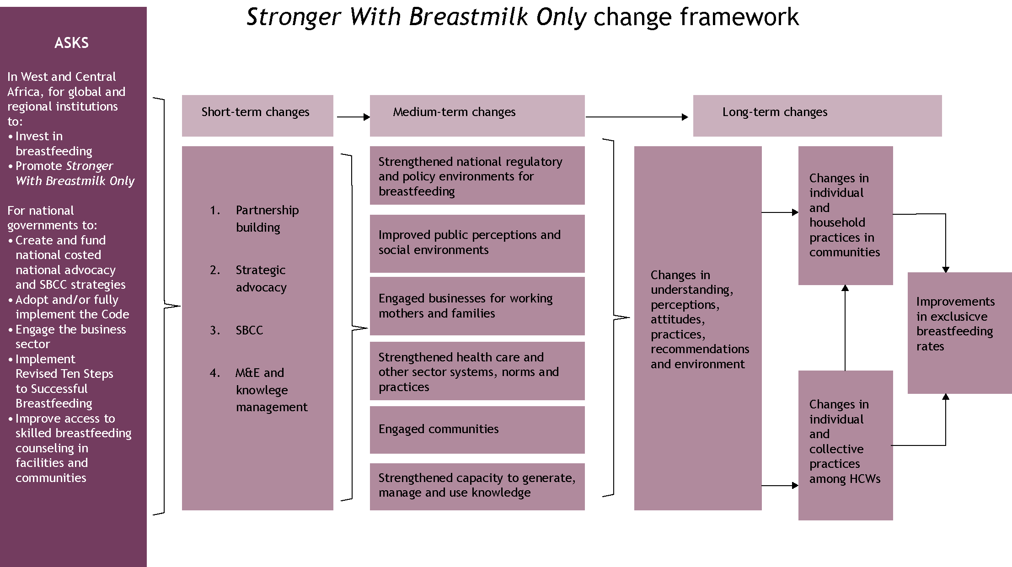

Figure 7: Stronger With Breastmilk Only change framework

Although the figure depicts a linear pathway that begins with advocacy, the process of change is multilevel, dynamic and circular in nature. Changes at household level--changes in understanding, perceptions, attitudes, beliefs, norms and practices--drive broader community change. At the same time, higher level changes in policies, systems, organizations, health and social services shape family and community practices. As expectations, norms and practices shift within families in favour of giving breastmilk only and not giving babies water in the first six months, these shifts can trigger the adoption of new practices in more families and communities and accelerate social change at a national level.
The Stronger With Breastmilk Only regional initiative centres on four programmatic approaches to ignite these changes:
- Approach 1: Partnerships. The Stronger With Breastmilk Only initiative relies on strong partnerships across sectors and organizations and led by national governments to accelerate positive change.
- Approach 2: Strategic Advocacy. The Stronger With Breastmilk Only initiative aims to strengthen the protection, promotion and support of breastfeeding through legislation and policies, including maternity protection and regulating the marketing and distribution of breastmilk substitutes, including packaged water to infants.
- Approach 3: Social and Behaviour Change (SBC). The initiative seeks to stimulate long-term social and behaviour changes at individual, family, community, health system and society level by implementing evidence-driven SBC activities.
- Approach 4: Monitoring and Evaluation (M&E) and Knowledge Management. The initiative uses M&E and research data strategically to strengthen programmes and fill gaps in understanding. Stronger With Breastmilk Only innovative and best practices will be disseminated to amplify initiative efforts across the region.

The framework for change is to be implemented with integration and sustainability in mind. Stronger With Breastmilk Only should not be a ‘stand-alone’ initiative with short-term results. National partners and programmes should embed initiative approaches, messages and tools into existing nutrition-specific and nutrition-sensitive programmes and platforms so that assets are maintained over time and communication is continuous. Integrating the Stronger With Breastmilk Only initiative into national programmes will facilitate rapid scale-up and sustainability.

Consult Annex 1 for more information on integrating Stronger With Breastmilk Only within nutrition-specific and nutrition-sensitive programmes.

The approach requires establishment of effective regional partnerships that create a supportive environment for improving exclusive breastfeeding rates across the region and accelerate change at national level. Regional and national partners include regional economic communities (ECOWAS and ECCAS, for example), professional associations, academic and research institutions, NGOs and other civil society organizations, think tanks and media networks and agencies. The table below lists ways in which partners can contribute to implementing Stronger With Breastmilk Only (Table 1).

Taken together, this integrated, multi-levelled approach engaging a network of partners will ultimately result in improvements in the practice of giving babies breastmilk only for the first six months of life.

Table 1: Regional partners’ contributions to Stronger With Breastmilk Only

Objective | Contributions
Create an enabling regional environment | - Build and mobilize partnerships  - Raise public awareness  - Strengthen commitment of regional and national institutions, leaders and influencers  - Generate evidence  - Support scale-up of innovation  - Manage knowledge
Accelerate results at national level | - Support national governments in the implementation of the Stronger With Breastmilk Only initiative  - Provide standard guidance, tools and guidance for advocacy and SBCC  - Facilitate sharing of experiences, lessons learned and good practices

II.4. Social ecological model

The social ecological model highlights the idea that behaviours shape and are shaped by the social environment; and that there are multiple influences within the social environment. It provides a lens through which to implement the initiative’s theory of change by helping conceptualize forces that facilitate and challenge decisions about exclusive breastfeeding. It shows that mothers and other caregivers of babies below age six months are at the centre, with layers of social influences affecting their feeding practices. The strongest influence comes from other household members, then an array of community actors – such as friends, peers and neighbours as well as formal and informal leaders, who are also social influencers, the health system and workplace. The outer ring represents structural forces that shape contexts for breastfeeding practices, including the broad socio-cultural context as well as government policy and regulatory systems.

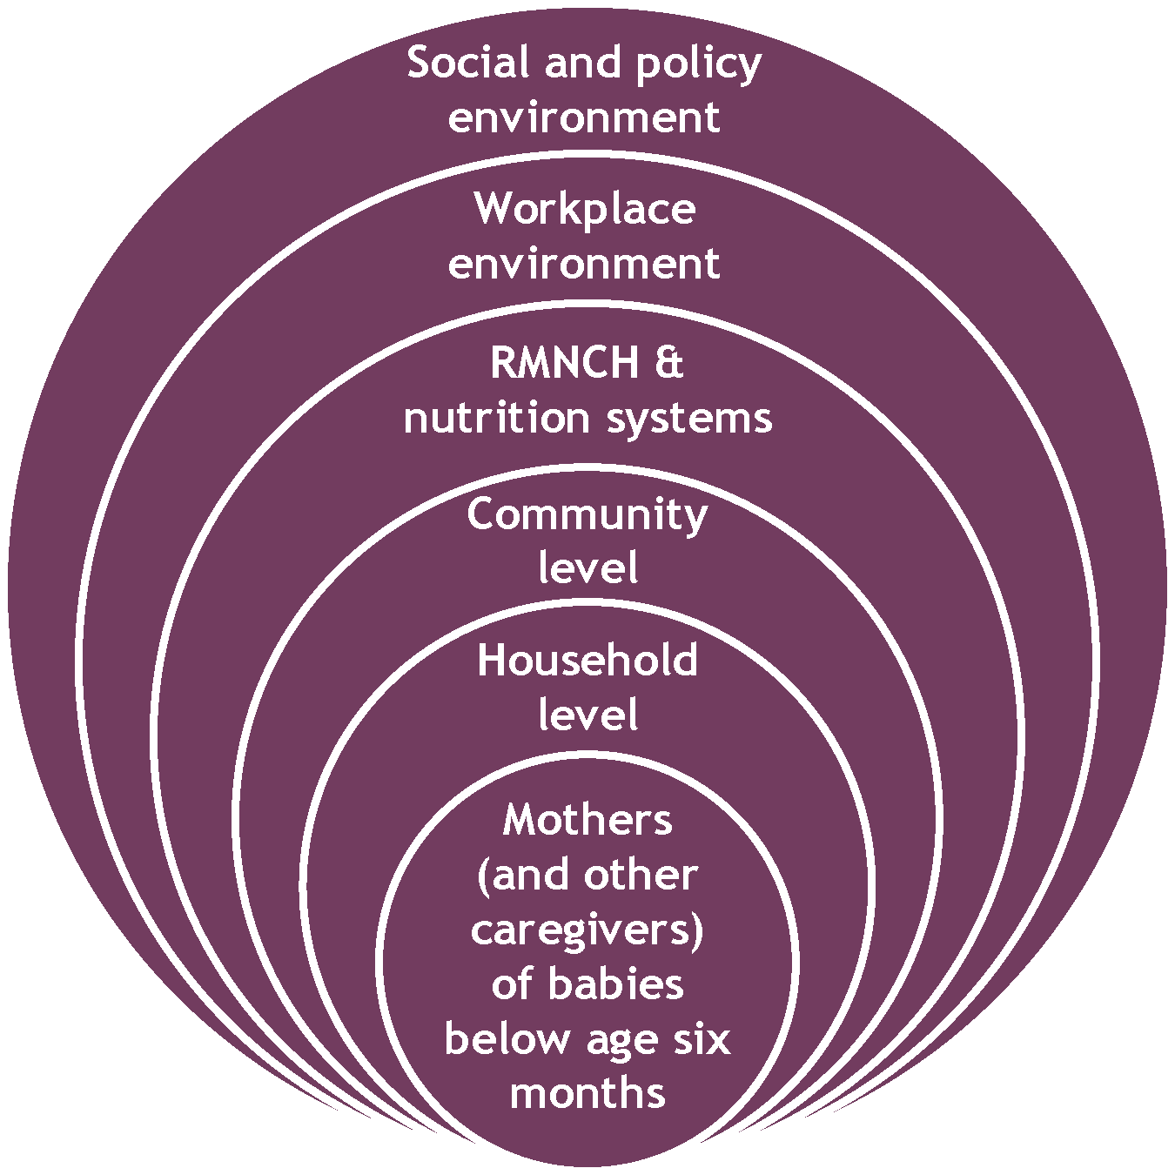

Figure 8. Social ecological model for Stronger With Breastmilk Only
The table below lists various people – or types of ‘change agent’ - who influence infant feeding practices in the first six months of life based on the review and programmatic evidence, and the role they play at each level depicted in the social ecological model.

Table 2: People of influence and their roles in breastfeeding decision-making by social ecological level

Level | People | Roles in breastfeeding decision-making
Individual | Mother (and baby) | The mother and baby are at the centre of infant feeding practices.  - The mother experiences pregnancy, gives birth, produces breastmilk, feeds and cares for her baby.  - Grandmothers and other caregivers feed and care for the baby.  - The baby communicates to her mother, grandmother and other caregivers through verbal and non-verbal behaviours that provide cues to caregiving actions. For example, a mother (or grandmother) may interpret a baby’s crying after having been breastfed as a sign that the baby is still hungry.
Household | Close family members who are caregivers and influence decision-making at the household level:  - Maternal and/or paternal grandmothers  - Other caregivers, such as aunts, siblings and day care providers  - Fathers | The attitudes, beliefs, experiences and practices of close family members influence acceptance and uptake of exclusive breastfeeding. They can influence the practice by:  - Encouraging and supporting exclusive breastfeeding  - Not offering water or any other substance to baby  - Reminding mothers that breastmilk supply can increase with increased suckling  - Support regular check-ups with health care providers
Community | Peers, neighbours, friends, as well as community leaders and other civic representatives:  - Civic leaders such as chiefs and sub-chiefs  - Opinion leaders, such as religious leaders  - Traditional birth attendants and healers  - Women’s groups  - Teachers  - NGO managers | Individuals belong to and identify with different types of communities based not only on geography but other factors such as, religion, culture, ethnicity, civil society, or media networks. Roles for these influencers include:  - Communicating and advocating for recommended breastfeed practices  - Serving as role models and supporting ‘Stronger With Breastmilk Only’ in the community  - Addressing community-level barriers to exclusive breastfeeding  - Supporting planning and tailoring of community health delivery activities and providing feedback to health providers  - Helping monitor ‘Stronger With Breastmilk Only’ activities
RMNCH and Nutrition Systems | Health managers at national and subnational levels.  Facility- and community-based health workers | Health managers strengthen, coach and supervise health workers and facilitate partnerships and engagement with NGOs and communities.  Facility- and community-based health workers are both influencers and, because they are community members, change agents. They play key roles in:  - Counselling about benefits of breastfeeding and added value of exclusive breastfeeding  - Supporting correct breastfeeding technique and troubleshooting difficulties  - Connecting mothers and caregivers with community role models for support
Workplace | Directors  Managers and supervisors  Co-workers  Health care providers  Business sector | Evidence consistently shows that work and study are impediments to breastfeeding for women with infants and young children.  Workplaces (and educational institutions) can play an essential role by:  - Implementing family-friendly workplace programmes, including maternity protection  - Ensuring space and time for breastfeeding or breastmilk expression
Social | Educators  Professional associations  Civil society  Media/Celebrities  Young people  Peer groups | Media, civil society, and celebrities can raise public awareness and shift social norms around exclusive breastfeeding by:  - Broadcasting stories and public service announcements on the benefits of exclusive breastfeeding and the dangers of giving water to babies under the age of six months  - Nurturing debates, role modelling and messaging to address social and behavioural determinants beyond knowledge  - Publicly recognizing women, families and communities who demonstrate exemplary breastfeeding practices  Young people embody the future in West and Central Africa. Youth can make a difference by:  - Spreading correct information through social media, peer groups and in their families  - Serving as role models in their communities when they become parents
Policy | Policy- and other decision-makers  Donors/UN  Academia /  Professional associations | Policy- and decision-makers, as well as representatives from professional associations, are able to:  - Influence national and subnational laws, policies and norms that guide medical and commercial practices  - Regulate the environment within which health care institutions, workplaces and commercial food and beverage businesses can operate and breastfeeding is promoted  - Invest in quality SBC programming

Regional objectives

III.1. Stronger With Breastmilk Only main objectives

The overarching objective of the Stronger With Breastmilk Only regional strategy is to increase the proportion of infants who receive breastmilk only from the moment of birth and for the first six months of life in West and Central Africa. The regional strategy focuses on one main and two related outcome-level objectives:

Main outcome-level objective:
- Increasing the proportion of infants who are given breastmilk only in the first six months of life.

Related outcome-level objectives:
- Increasing the proportion of newborns who are breastfed within the first hour of birth.
- Decreasing the proportion of breastfed infants who receive plain water (other liquids or foods) in the first six months of life

III.2. Stronger With Breastmilk Only specific objectives

The Stronger With Breastmilk Only SBC initiative posits that undesirable infant feeding practices, such as giving infants younger than six months water, other liquids and foods, can be shifted in favour of exclusive breastfeeding by identifying the drivers of these practices, and mobilizing specific forces for change within families, communities and nations.

The regional SBC objectives in Table 3 below reflect the analysis of data collected through the situation analysis.

Tables 3-8. Desired behaviours and SBC objectives by type of ‘change agent’ based on SBC determinants

Table 3: Change agent: Mothers

What is the desired behaviour? | What determines the desired behaviour? | What are the SBC objectives?
At the time of birth
Start breastfeeding from the first hour of your baby’s life | - Skilled birth attendance: access and choice  - Knowledge of benefits  - Beliefs regarding quality and availability of breastmilk in the first days after delivery  - Beliefs regarding mother’s and baby’s needs and conditions after birth (baby’s cues) | - Increase motivation and ability to access ANC and skilled birth attendance  - Improve perceived importance of initiating breastfeeding in the first hour after birth  - Increase perceived risk of delaying initiation of breastfeeding  - Increase motivation and ability to initiate breastfeeding in the hour after birth in special circumstances such as: c-section, multiple birth, low birth weight birth, illness/HIV etc.  - Address misconceptions regarding quality, availability and benefits of first breastmilk (colostrum)  - Improve understanding and skills to facilitate breastfeeding and breastmilk production in the first hour and days of a baby’s life
Welcome newborn without feeding water or other liquids | - Religious and/or cultural traditions include giving water/other liquids and delaying breastfeeding to welcome newborn | - Increase awareness of risks of giving newborns water and other liquids in the first hours or days after birth  - Propose alternative ways to welcome newborns without giving water, other liquids or foods
During the infant’s first six months of life
Breastfeed (give breastmilk) only and on demand for the infant’s first six month of life | - Understanding of exclusive breastfeeding recommendations  - Perceived self-efficacy  - Intention  - Knowledge of the added benefits of giving breastmilk only  - Perceptions related to quality of breastmilk and breastmilk supply  - Perceived costs of exclusive breastfeeding: convenience, effect on body shape and baby’s behaviours  - Perceptions regarding supplements (water, liquids, foods)  - Barriers related to baby’s conditions and behaviours  - Barriers related to mother’s health conditions (psychological and physical)  - Health care preferences  - Past experiences (self and others)  - Locus of control/Autonomy  - Social influence and support  - Social norms related to water | - Increase maternal and family intention to give breastmilk only  - Improve mastery of breastfeeding, including ability to overcome physical barriers to breastfeeding  - Improve perceived self-efficacy to give breastmilk only  - Improve understanding of  - the meaning and duration of exclusive breastfeeding  - the benefits of breastmilk and added value of giving breastmilk only  - Increase perceived risks of giving water, other liquids and foods  - Correct misconceptions related to maternal and infant conditions required for breastfeeding  - Improve understanding of and ability to respond to baby’s needs, cues and behaviours (for example, baby’s stomach size, signs of hunger and sufficient breastmilk intake)  - Increase access to emotional, practical and social support from the baby’s father, grandmother, other family members and entourage, including promoting positive examples and experiences with giving breastmilk only
Do not give water for the first six months of life  Breastfeed baby to quench thirst  Wait until the baby is six months old to give safe water (in small quantities) | - Perception of breastmilk quality and supply  - Lack of availability or absence of mother  - Adaptive understanding and behaviours related to giving water  - Social norms related to water | - Correct misconceptions regarding breastmilk composition, nutritional value, supply and safety  - Increase perceived importance and advantages of giving breastmilk only and risks of giving water to babies in first six months of life and contribution to undernutrition and poor physical and intellectual development  - Increase perceived locus of control and self-efficacy to not give water to babies in first six months of life  - Improve access to positive genuine examples and experiences of not giving water (giving breastmilk only)
Go to the health centre to monitor the baby’s growth and development and in case of illness | - Health care preferences: preference to consult with traditional healers to ensure healthy growth and development and treat when baby is sick | - Improve knowledge of causes, signs of and perceived risk of undernutrition  - Improve understanding of importance and benefits of well-baby visits, routine vaccinations and appropriate care of the sick child aged below six months  - Increase access to health centre for well-baby visits and when the baby is sick  - Improve husband’s and household awareness and support for routine attendance of well-baby visits and appropriate care of a sick baby
For situations where the mother is not available to breastfeed the baby
Express and store breastmilk to give to the baby when the breastfeeding mother is not available | - Availability of the mother to breastfeed  - Skills related to expressing, handling and storing breastmilk  - Beliefs regarding safety of expressed breastmilk | - Increase knowledge of possible solutions for achieving giving breastmilk only when the mother is not available (work, school, travel, etc.)  - Increase knowledge of the benefits and safety of breastmilk expression, storage and handling  - Promote mastery of breastmilk expression  - Promote skills in appropriate storage and handling of expressed breastmilk  - Increase community, social/public support for breastmilk expression, storage and feeding of expressed breastmilk  - Increase access to breastfeeding support in institutional and public settings (work, schools, markets, etc.)
From six to 24 months of age
When the baby is six months old, introduce first food such as enriched porridge or mashed fruits or vegetables progressively | - Knowledge of when and how to initiate complementary feeding  - Cues to action: complementary foods are introduced in response to baby’s behaviours | - Increase knowledge of when and what types of first foods to introduce at age of six months  - Increase skills in safe food preparation, feeding and hygiene  - Increase access to first foods  - Improve household and community awareness and support
Continue breastfeeding or giving breastmilk until the child is 24 months old | - Knowledge and skills  - Self-efficacy | - Increase understanding of importance and benefits to continue breastfeeding up to 24 months of age  - Reinforce continued breastfeeding behaviours as a positive nutrition and parenting practice

Box 2: Segment mothers to tailor counselling and problem-solving to their needs

Mothers’ needs for information and support vary according to their unique situations and perceived needs. Segmenting mothers into smaller groups that share similar characteristics helps to tailor counselling and messages according to these different needs. Findings from the regional literature review identified different criteria to segment mothers.

Moment in the continuum of reproductive, maternal, newborn and childcare.
- During pregnancy: Counselling all expectant mothers on the benefits of giving babies breastmilk only and risks of giving water, other liquids and foods in the first six months of life helps them and their families to anticipate needs, plan ahead, and make decisions that facilitate giving breastmilk only from the moment of birth and for the first six months of life.

- At the time of delivery. All mothers should receive breastfeeding support at the time of birth to initiate breastfeeding within an hour of birth. This is particularly important for mothers facing special circumstances, including birth by caesarean section, of multiple babies or of a low birth weight baby. These mothers may require special counselling and skill-building support to initiate and establish exclusive breastfeeding.

- Infant age. Data from West and Central Africa reveal two key moments when exclusive breastfeeding rates tend to drop. The first is at one month; the second is between three and four months. These are key times to strengthen counselling and support for mothers to maintain exclusive breastfeeding.

Birth order.
- First-time mothers: First time mothers may be more sensitive to and be expected to receive the guidance of their elders. Female elders may also be more motivated to share their knowledge with first-time mothers.

- Mothers of multiple children: Breastfeeding practices may change from one infant to another based on new understanding, observations and experiences.

Occupation.
- Mothers who work or study: Anticipatory counselling is especially important for mothers on maternity leave who must prepare for their return to work. Moments when mothers are unavailable – due to work, study or household chores – are times when water, other liquids or foods may be given to satisfy the baby. Providing practical solutions and support in these situations is essential to maintain exclusive breastfeeding.

Attitudes and practices.
In communities where giving babies water in the first six months of life is the social norm, ‘positive deviants’ or trendsetters (Bicchieri, 2017) are the innovators and early adopters who willingly embrace changes in breastfeeding practices to give breastmilk only during the first six months of the baby’s life. Trendsetters are important for SBC because of the role they play as opinion leaders and in role modelling of desired behaviours and small doable actions.

Table 4: Change agents in homes: Grandmothers and other female caregivers.
Caregivers are the people, most often women, who take care of the baby while the mother is busy. They can be a grandmother, aunt, older sibling or nanny. The caregiver may be given the responsibility or feel compelled to feed the baby in the mother’s absence.
Desired behaviours | Social and behavioural determinants | SBCC objectives
There are many ways in which grandmothers and other female caregivers can act to support exclusive breastfeeding:  Ask for baby to be placed on mother’s breast immediately after delivery  Encourage mother to breastfeed/give breastmilk only on demand for the baby’s first six months of life  Avoid offering water or any other substance to baby at birth or in the first six months of life  Feed baby expressed breastmilk in the absence of the mother  Help with household chores to free mother’s time to breastfeed, to eat, rest etc. | - Beliefs  - Emotional and practical support  - Intention  - Social norms and change related to giving water | - Increase levels of emotional, practical and social support for early initiation of and exclusive breastfeeding for the first six months of the baby’s life.  - Improve household-level/family support to not give water

Table 5: Change agents in homes: Husbands

Desired behaviours | Social and behavioural determinants | SBCC objectives
There are many ways in which husbands can act to support exclusive breastfeeding:  Accompany pregnant wife (or partner) to ANC  Improve access to more diverse and frequent nutrition during pregnancy and lactation  Encourage mother to breastfeed/give breastmilk only on demand for the baby’s first six months of life  Give practical support – with household chores for example – to free mother’s time to breastfeed | - Husband’s support  - Intention  - Self-efficacy  - Social norms and change related to giving water | - Increase levels of emotional, practical and social support for early initiation of and exclusive breastfeeding for the first six months of the baby’s life.

Table 6: Change agents in health care centres and extending into communities: health care workers and community health workers

Desired behaviours | Social and behavioural determinants | Provider behaviour change objectives
At the moment of birth
Place the baby on the mother’s chest and facilitate initiation of breastfeeding within an hour after birth | - Association between skin-to-skin contact and early initiation of breastfeeding  - Association between early initiation of breastfeeding and exclusive breastfeeding  - Beliefs regarding quality, availability and safety of breastmilk in the first days after delivery  - Beliefs regarding mother’s and baby’s needs and conditions after birth (baby’s cues) | - Raise awareness of the importance of HCWs’ role in early initiation of exclusive breastfeeding (supported by evidence)  - Improve knowledge of life-saving benefits of  - Skin to skin contact  - Initiating breastfeeding in the first hour of a baby’s life  - Increase understanding of risks related to delaying initiation of exclusive breastfeeding  - Correct misconceptions related to breastfeeding/giving breastmilk in special circumstances, including: c-section deliveries, multiple birth, premature birth, illness/HIV etc.  - Improve HCWs ability in skilled breastfeeding counselling  - Implement quality improvement systems that take into account the importance of early initiation of exclusive breastfeeding
Welcome newborn without feeding water or other liquids | - Cultural traditions to welcome newborn | - Increase perceived risk of giving newborns water and other liquids in the first hours or days after birth  - Improve capacity in counselling to shift/adapt undesirable newborn feeding and care practices  - Improve HCW support to stop giving water
In anticipation of and during the first six months of the baby’s life
Provide skilled counselling and support for breastmilk only, no water | - Perception of breastmilk supply  - Misconceptions drive recommendations to supplement breastmilk with water, other liquids or foods  - HCW communication:  - Confused or adapted messages  - Communication barriers  - Low self-efficacy to change family practices  - Lack of skills to dialogue around issues in a persuasive manner  - Credibility issues: Inconsistency between HCW discourse and practice | - Improve understanding of the importance of skilled breastfeeding counselling during ANC visits  - Increase perceived ability and self-efficacy to dialogue with mothers and family members about changes in family practices in favour of exclusive breastfeeding  - Increase ability to tailor breastfeeding counselling to special circumstances, such as adolescent pregnancy, single mothers, HIV, chronic illness, working mothers, new pregnancy, etc.  - Improve understanding (correct misconceptions) of  - the definition and duration of exclusive breastfeeding  - the benefits of breastmilk and added value of giving breastmilk only  - breastmilk composition (water + food), nutritional value, supply and safety  - negative outcomes related to giving water, other liquids and foods  - maternal and infant conditions required for breastfeeding  - infants’ needs, cues and behaviours related to nutrition (early childhood development/parenting)  - Improve acceptance and ability to teach and support mothers’ breastmilk expression, storage, handling and feeding  - Improve HCW support to stop giving water

Table 7: Change agents in communities: Community leaders, religious and other opinion leaders, community members

Desired behaviours | Social and behavioural determinants | Community engagement objectives
Encourage giving breastmilk only, without giving water, other liquids and foods in the first six months of a baby’s life | - Community experiences and support: communities with a good number of mothers who practice EBF tend to motivate other mothers to do the same  - Social norms related to giving water  - Religious and/or cultural traditions include giving water/other liquids to welcome newborn and delaying breastfeeding | - Increase community, religious, traditional and female opinion leaders’ awareness of risks of giving newborns water, herbal remedies and other liquids in the first hours or days after birth  - Engage community and other opinion leaders to sensitize community members on the importance of exclusive breastfeeding from the first hours to the sixth month of life  - Engage religious leaders and traditional healers to modify ceremonies or practices to prevent giving newborns and babies water or other liquids  - Create improved community support systems for mothers of young babies, such as day care.  - Increase community, social/public support for not giving water

Table 8: Change agents in society in general: Young people and the public in general

Desired behaviours | Social and behavioural determinants | Social change objectives
Call for and model a positive social and cultural environment for giving breastmilk only, without giving water, other liquids and foods in the first six months of a baby’s life | - Social norms related to breastfeeding and giving water  - Intergenerational and gender norms | - Raise public awareness and understanding of the importance of breastmilk only, no water for the first six months of life  - Shift social expectations and sanctions related to giving water in order to achieve social norm change  - Increase community, social/public support for not giving water  - Call for enforcement of Maternity Protection and the International Code of Marketing of Breastmilk Substitutes policies, also in relation to unethical marketing and promotion of packaged water

Approaches and activities, and specific guidance for communication and advocacy

IV.1. Lessons learned
Evidence shows that successful exclusive breastfeeding programmes adopted people-centred interventions to change individual and household behaviours and social norms. These interventions built on community assets, addressed barriers and increased social support for exclusive breastfeeding by using a combination of communication activities employing multiple channels (UNICEF, 2010; Sanghvi et al, 2013; Menon, 2016; Alayon and Jimerson, 2018).

Successful breastfeeding programmes implemented:
- Policy advocacy to create more supportive national policies and legislation for breastfeeding.
- Mass media campaigns for social change using relevant media channels to reach all participant groups and influence social change.
- Health systems strengthening and provider behaviour change to increase the number of contacts and opportunities for dialogue with health care workers for skilled breastfeeding counselling.
- Community engagement to strengthen understanding and support for breastfeeding in communities.
- Interpersonal and group communication to incite dialogue, increase self-efficacy, address barriers and create support for exclusive breastfeeding.

The table below presents different approaches and activities, based on a review of global evidence of effectiveness, that countries can use to influence social and behaviour change at different levels of influence.

Table 9: Level of influence (left side) and corresponding SBC approaches, activities and channels (right side)

Level of influence |  | SBC approach | SBC activities | SBC channels
National environment:  - legislative | -> | Policy advocacy | - Integration of Stronger With Breastmilk Only initiative objectives into SUN networks, other networks, other government sectors and national programmes  - Enactment and strengthened monitoring of the International Code of Marketing of Breastmilk Substitutes (‘the Code’), especially regarding unethical marketing and promotion of packaged water  - Enactment and strengthened monitoring of Maternity Protection and other family friendly workplace policies  - Fundraising for Stronger With Breastmilk Only and increased community coverage of breastfeeding counselling | - High-level meetings and workshops  - Engagement of Parliamentarians, business associations, professional associations, civil society organizations, women’s groups, academics and other champions  - Media
National environment:  - social | -> | Social change | - Public and youth awareness raising, positive modelling and advocacy campaigns for social change | - Mass media edutainment, such as C’est La Vie  - Social media, such as U-Report  - Celebrity engagement
Workplace environment | -> | Policy advocacy  Organizational change | - Workplace family friendly policies and support systems, including breastfeeding support | - Organizational leadership and management  - Labour unions  - Professional training, workshops and routine meetings
RMNCAH and nutrition environment | -> | Health systems strengthening  Provider behaviour change | - Implementation of the 10 Steps to Successful Breastfeeding (Baby Friendly Hospital Initiative)  - Community health coverage  - Capacity building in: skilled breastfeeding counselling, breastmilk expression, storage and feeding, persuasive dialogue and demonstrations and community engagement  - Quality improvement systems | - Curriculum design (pre- and in-service)  - On-the-job learning and job aids  - Supportive supervision and performance recognition  - Community accountability mechanisms
Community environment | -> | Community mobilization  Positive deviance/diffusion of innovations approaches | - Mobilization of community leaders, religious and traditional health care leaders and other opinion leaders  - Community dialogue and engagement approaches | - Community media such as radio  - Community events  - Mother-to-mother support groups  - Women’s groups  - Men’s groups
Interpersonal and household environment | -> | Interpersonal and group communication  Family systems | - Mother mentors/breastfeeding role models  - Grandmother approach  - Father involvement | - Home visits  - ANC and PNC visits  - Routine immunization /well and sick baby visits
Individual (Mothers and other caregivers of babies aged under six months of age) | -> | Interpersonal and group communication | - Knowledge, skills and perceived self-efficacy building  - Social support | - Interpersonal communication  - Group support

Consult Annex 2 for more information about some key SBC theories and conceptual models underpinning these approaches and that can be used when designing the Stronger With Breastmilk Only national advocacy and SBC strategy.

BOX 3. U-REPORT SUPPORTS THE STRONGER WITH BREASTMILK ONLY REGIONAL INITIATIVE

The UNICEF U-Report social media platform is supporting the Stronger With Breastmilk Only initiative in West and Central Africa by raising awareness and encouraging dialogue around giving babies breastmilk only in the first six months of life, promoting citizen (youth) feedback on the initiative and monitoring changes in understanding of exclusive breastfeeding and in reported behaviours over time. U-Report provides young people with the opportunity to express their opinion and be positive agents of change in their communities.

During 2019 World Breastfeeding Week, U-Reporters in West and Central Africa participated in a Stronger With Breastmilk Only awareness-raising campaign, which included pre- and post-survey polls, one-on-one live-chats and received tailored messages on giving babies breastmilk only, no water in the first six months of life.

A total of 10 countries participated in the campaign.
150,000 U-Reporters responded to the pre-campaign survey poll, among whom 56 per cent were parents. Results from the pre-campaign poll highlighted the need to increase understanding of recommended breastfeeding during a baby’s first six months of life:
- 55 per cent believed babies need water in the first six months of life
- 45 per cent believed babies should be given something in addition to breastmilk to grow strong and healthy.

Following the poll, U-Reporters received access to breastfeeding information on the Internet of Good Things (IoGT) https://www.internetofgoodthings.org/section/nutrition-and-breastfeeding/ key breastmilk only, no water messages and, in some countries, were able to participate in a live chat during which questions were answered. In Nigeria, the live chat responded to 26,000 questions on topics including exclusive breastfeeding, maternal health and benefits of breastfeeding.

The Post-campaign survey poll in which 128,474 U-reporters participated revealed a shift in reported perceptions and behaviours, with
- 23% decrease in U-Reporters opinions that babies need water during the first six months
- 16% increase in knowledge of exclusive breastfeeding during the first six months
- 8 % decrease in U-Reporters behaviours of giving babies food other than breastmilk

IV.2. Communication guidance

This sub-section describes some key guidance to take into consideration when implementing Stronger With Breastmilk Only communication.

IV.2.1. Define ‘exclusive breastfeeding’
While the term ‘exclusive breastfeeding’ is understood by nutrition experts and most health professionals, studies reported on gaps in understanding of the meaning of ‘exclusive breastfeeding’ among both mothers and health professionals (2016). Some mothers considered that they practiced ‘exclusive breastfeeding’ even when they gave water to their infants younger than six months (Murray et al., 2008 and Ostergaard and Bula, 2010, Nor et al., 2012, Nduna et al., 2015). Some health professionals shared similar misconceptions, as indicated by their recommendations of supplementary feeding at the same time as exclusive breastfeeding.

To address these challenges, the following tips for communication should be followed when communicating with mothers and health professionals about breastfeeding:
- Reconsider the use of the word ‘exclusive’ during communication about exclusive breastfeeding. Instead, talk about ‘giving breastmilk only, no water, other liquids or foods’.
- Emphasize that giving water in the first six months of life is unnecessary and can be harmful.
- Explore mothers’ and health professionals’ understanding of the meaning and practice of exclusive breastfeeding by asking open-ended questions, listening carefully, then present information with their understanding in mind.

IV.2.2. Use Stronger With Breastmilk Only branding

The campaign name Stronger With Breastmilk Only aims to effectively promote the benefits of exclusively breastfeeding for the first six months of life. The tagline “No water until 6 months for a healthier baby” further emphasizes the need to stop the practice of giving water (and other liquids and foods), from the moment of birth through the first six months of life, to help babies grow strong and healthy. Additionally, the look and feel of the branding - which highlights the figure of a breastfeeding woman alongside her mother and husband - is a direct call-to-action for everyone to join together in support of breastfeeding mothers in West and Central Africa.

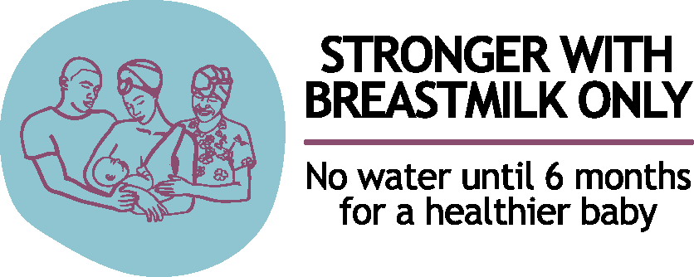

It is critically important that the same branding is used across the campaign efforts, whether at the regional, national or local level, so that the campaign remains consistent and recognizable. In this type of campaign, with multiple levels of implementers across different contexts, the branding acts as a way to tie various activities together into a cohesive effort which becomes familiar to stakeholders, key audiences and beneficiaries.

The Stronger With Breastmilk Only branding guidelines.

IV.2.3. Consider these creative insights when communicating Stronger With Breastmilk Only

Strive for intensity
Create multiple opportunities to discuss key messages with change agents, including mothers, HCWS, grandmothers and communities.

It is important to emphasize that that Stronger With Breastmilk Only SBC messages proposed below:
- need to be adapted based on local evidence
- can be conveyed in different forms and
- should include specific messages to address priority barriers.

Here are some of the key messages:
- Give babies breastmilk only, on demand (day and night) – no water, other liquids or foods – from the moment of birth and for the first six months of life.
- Breastmilk is the most uniquely adapted, safest, healthiest and best source of food and water for babies from the moment of birth and for the first six months of life, no matter where they live.
- Breastmilk contains 88% of water. When provided on demand (day and night), breastmilk meets the water requirements for babies aged under six months with a considerable margin of safety, even in hot and dry climates.
- Giving water – and other liquids and foods in the first six months of life, is harmful for your baby.
- Giving breastmilk only, helps protect your baby from illness and undernutrition, and offers all the water and food your baby needs to grow healthier, stronger and smarter.

Use emotion to appeal to the target audience
Emotions attract audiences’ attention, and help them remember, share and trigger action. Emotions can be powerful drivers for change.

Watch Alive & Thrive’s TV spot aired in Vietnam, which used talking babies to appeal emotionally to mothers and caregivers and drive the ‘no water’ messages. The TV spot messaging addressed explicit beliefs about giving water and built mothers’ confidence that breastmilk alone is sufficient for babies under six months
https://www.youtube.com/watch?v=-wIWFlr3xNE
Listen to the presentation on ‘The Secret Life of No Water’ by Phan Thi Hong Linh, Senior Technical Specialist, PR and Advocacy, Alive & Thrive South Asia, focusing on the five key takeaways from the implementation of Alive & Thrive Vietnam’s ‘No Water’ mass media Campaign. https://www.youtube.com/watch?v=JxyL7mEORBw

Consider barriers and facilitators of exclusive breastfeeding in communication

Table 10. Some key facilitators and barriers to consider in communication

Facilitators | Barriers
A valued practice. Breastfeeding is highly valued. It is the approved and expected practice and a part of maternal identity in West and Central Africa.  The power of visual proof - “seeing is believing”:  Experiential learning and use of visuals enhance understanding and can help persuade mothers that breastmilk contains enough water, even in hot and dry climates (Box 4).  Seeing the effect of exclusive breastfeeding on babies is a persuasive proof of concept to families. Babies who are given only breastmilk, no water (other liquids or foods) look healthier, more alert and are less sick.  For example, in Ghana, during a community-based breastfeeding promotion initiative in Upper East Region, some community leaders decided with their communities to conduct community-based trials of improved breastfeeding practices to observe differences between babies who were exclusively breastfed and those who were not. NGO-monitored exclusive breastfeeding rates rose as a result confirming that experience can be a powerful means of persuasion and social and behaviour change  Focus on the mother’s thirst, rather than the baby’s: Giving the mother water helps quench the mother’s thirst while breastfeeding and may reassure the mother and her family members that the baby will receive enough water while breastfeeding.  In some programmes, communication activities have successfully managed to persuade mothers to stop giving water by saying that the mother should drink the water. The baby will receive the water through the mother’s breastmilk.  Work with influential people to champion the cause. Winning support from celebrities and other influential people to champion breastmilk only, no water increases visibility of respected and attractive role models. | - Though breastmilk is perceived to be the best nutrition, there are misconceptions that breastmilk does not contain enough of what is needed to ensure the optimal growth and development of the baby and that breastmilk can also be dangerous in certain circumstances (‘quality’ issues). ‘Spoiled’ breastmilk poses a threat to the baby’s well-being. It is believed to be a cause of diarrhoea. Water may be given as a substitute for ‘spoiled’ breastmilk.  - In hot and dry climates, particularly in the Sahel region, water is given because it is believed that breastmilk cannot quench thirst. People fear the baby may die of thirst if she does not receive water. Giving water is socially expected that may be sanctioned when this practice is not respected.  - Another misconception is that mothers cannot produce enough breastmilk to satisfy a baby’s needs (quantity issues).  - Some young women may resist breastfeeding exclusively because of the unwanted effects they think it will have on the appearance of their body (esp. breasts) and fear the disinterest and lack of attention from their husbands or partners.

BOX 4: Visualize the separation of fat from liquid in breastmilk or other milk.
This can be a powerful way to support the ‘breastmilk is enough, no need for water’ message.  The photograph to the right shows the foremilk (left side) or the first portion of milk that a suckling baby receives, which is composed mostly of water, and the hindmilk (right side), rich in fat and delivered as the breast empties. Breastmilk naturally addresses first a baby’s thirst (foremilk) and then hunger (hindmilk). The energy density of milk increases significantly during a feed: from 15–17 kcal/ounce early to 25–27 kcal/ounce late. Protein and lactose concentrations remain constant throughout a feeding. | 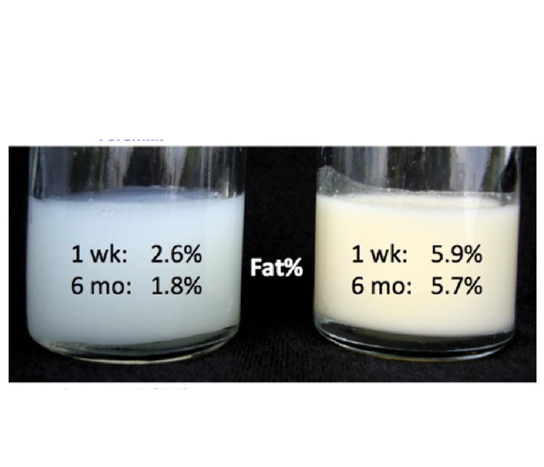

Anticipate unintended negative consequences
- Avoid language and visuals that blame or stigmatize mothers who are unable to breastfeed or exclusively breastfeed. Negative emotions, such as disappointment and shame, are felt when mothers are unable to breastfeed as they are expected to.
- Be aware that the expression “no water” may elicit strong negative reaction particularly in places where water is scarce and difficult to access.
- Be careful about restricting messages only to not giving water, which may misplace behaviours to giving other giving other liquids or foods instead of giving breastmilk only.
- Work with WASH partners to ensure consistent messages across programmes and initiatives.

Annex 3. Consult the Stronger With Breastmilk Only SBC messaging table for examples of messaging themes and content related to the initiative from existing global and national resources. Sample messages should be adapted to national context.

IV.2.4. Stronger With Breastmilk Only communication tools

The following communication products are available for countries to adapt

Stronger With Breastmilk Only Community-level counselling cards: https://breastmilkonly.org

Stronger With Breastmilk Only community radio pack: https://breastmilkonly.org

Other resources that can be used for the implementation of Stronger With Breastmilk Only SBC strategy include:

GLOBAL HEALTH MEDIA VIDEOS: https://globalhealthmedia.org/videos/

INFANT AND YOUNG CHILD FEEDING IMAGE BANK : https://iycf.spring-nutrition.org/

IV.3. Advocacy guidance

IV.3.1. Strategic advocacy objective
Strategic advocacy aims to persuade national decision-makers to adopt and implement evidence-informed regulations, policies and social and behaviour change activities that protect, promote and support breastfeeding and integrate ‘breastmilk only, no water (other liquids or foods)’ messaging to increase exclusive breastfeeding rates nationally.

The initiative’s call for investing a comprehensive approach to breastfeeding. This is defined around specific policy and programme asks:
- Create national breastfeeding strategies and costed implementation plans that address the SBC determinants of infant feeding, including the practice of giving water, at the moment of birth and for the first six months of life.
- Adopt and fully implement the Code, including legislation on labelling of bottle water.
- Enact and strengthen monitoring of Maternity Protection and other family friendly policies, and engage the business sector in providing breastfeeding time, space and support to working mothers.
- Implement the Ten Steps to Successful Breastfeeding to improve access to skilled breastfeeding counselling and reinforce community coverage.

IV.3.2. Most important thing to say to leaders, decision-makers and programme planners
Invest in exclusive breastfeeding: a simple behaviour with a high return on investment. Initiating exclusive breastfeeding within an hour of birth and continuing for the first six months of life save children’s lives, prevents disease and undernutrition, promotes children’s growth, health and development and build a nation’s ‘grey matter infrastructure’.

IV.3.3. Key insights regarding decision-makers
- Decision-makers may share the same beliefs (and feelings) around the necessity of giving water and should be persuaded that giving water in the first six months of life is not necessary and can increase likelihood of childhood diseases – like diarrhoea and respiratory infections– and undernutrition.
- In places where giving water is common, decision-makers can easily relate to the issue. Decision makers understand quickly the SBC context and challenges and engage in the issue because of their personal experience and observations.
- Engaging respected high-level breastfeeding experts and change-makers can influence decision-making in favour of the protection, promotion and support to breastfeeding.
- There is a need to shift the marketing (and popular image) of packaged water as healthy for babies to being harmful to babies in the first six months of life. Enactment and monitoring of the Code helps provide an enabling context for this.

IV.3.4.Spotlight on ‘breastmilk only, no water’ advocacy
The following table place the spotlight on stopping the practice of giving water for the first six months of life using a practical “problem – solution – impact – call to action” model.

Table 11. ‘Problem – solution – impact – call to action’ model for ‘breastmilk only, no water’ advocacy

The problem | In many countries of West and Central Africa, while breastfeeding is ubiquitous, exclusive breastfeeding is not. The practice of giving babies water in the first six months of life is the main obstacle to improving exclusive breastfeeding rates in the region. On average, only three out of every ten infants in the region are exclusively breastfed. Four out of the remaining seven are given plain water in their first six months of life (UNICEF, 2019).  Depending on the country and context, giving babies water may  - Happen in the first few days of birth to welcome and/or bless the newborn, and/or to satisfy the newborn until the mature (white) breastmilk arrives.  - Is a socially expected practice, which is sanctioned when there is non-compliance.  - Is an alternative to breastmilk when the mother is not available.  Across the region, various brands of packaged (bottled) water promote the benefits of their water for babies.  Giving water (other liquids and foods) initiates a perilous cycle that challenges the physical, emotional and intellectual growth, health and survival of babies.  - In low- and middle-income countries, infants who received mixed feeding (foods and liquids in addition to breastmilk before 6 months) were up to 2.8 times more likely to die than those who were exclusively breastfed (Sankar, 2015).  Giving water (other liquids and foods) during the first six months of life harms the development and growth of babies because:  - Babies stomachs are small and easily filled.  - Liquids and foods replace uniquely adapted nutrient-rich breastmilk with substances with no or less nutritional value.  - These foods and liquids may carry harmful bacteria and carry a risk of infection and disease. This can make babies weaker and contributes to malnutrition.  - Liquids and foods damage a baby’s digestive tract, which reduces his ability to absorb needed nutrients.  - Liquids and foods introduce diarrhoea and respiratory diseases-causing germs and other pathogens from contaminated water or feeding utensils.  - Babies who are fed other foods or fluids will suckle less vigorously at the breast. This reduces a baby’s demand for her mother’s breastmilk, which thereby reduces a mother’s breastmilk supply. The amount of breastmilk produced naturally adjusts in response to the baby’s demand.
The solution | Increasing exclusive breastfeeding rates in West and Central Africa sustainably and at scale requires addressing in the policy, commercial, social and behavioural drivers of giving water (and other liquids and foods) in national programs. The design and implementation of a national evidence-informed and costed Stronger With Breastmilk Only strategy is needed to do this.
The impact | A multi-component Stronger With Breastmilk Only social and behaviour change communication campaign implemented by Alive & Thrive in Vietnam from 2010 to 2014 demonstrated that combined use of television and interpersonal communication resulted in improvements in exclusive breastfeeding rates - from 24 to 56 percent (Nguyen et al. 2017).
The call to action | - Enact or strengthen legislation to implement the International Code of Marketing of Breastmilk Substitutes and relevant WHA resolutions. Monitor and enforce the legislation (or the Code in its absence), with an emphasis on companies that manufacture or distribute packaged water.  - Raise awareness among manufacturers and distributors of packaged water about their responsibilities under the Code and national legislation.  - Integrate Stronger With Breastmilk Only activities into breastfeeding-related strategies and costed implementation plans.  - Implement a multicomponent Stronger With Breastmilk Only social and behaviour change communication strategy.  - Enact and strengthen implementation of maternity protection and workplace breastfeeding support.  - Implement the Ten Steps to Successful Breastfeeding.

Consult Annex 4 for information that supports the claim of no need for water in the first six months of life discussed in the following resources: 1) the revised Baby-Friendly Hospital Initiative (BFHI) guidelines and 2) WHO’s evidence-based policy brief on “No need to give water to exclusively breastfed infants in hot and arid conditions”.

IV.3.5. Stronger With Breastmilk Only advocacy materials

The Stronger With Breastmilk Only Advocacy Pack includes:
- Video
- Power Point presentation
- Podcast
- Infographic
- A call to protect, promote and support breastfeeding in West and Central Africa
- Fact Sheet: Breastmilk, the only source of water and food babies need for the first six months of life.
- Advocacy guidance: Invest in breastfeeding
- Advocacy guidance: Enforce regulations to protect breastfeeding
- Advocacy guidance: Improve access to skilled breastfeeding counseling
- Advocacy guidance: Give breastmilk only. Guidance for policy and programme managers

Monitoring and documenting Stronger With Breastmilk Only

V.1. Stronger With Breastmilk Only results tracker
The results tracker describes indicators that can be used to monitor progress in Stronger With Breastmilk Only initiative implementation at national level (Table 12). Countries should prioritize the indicators they wish to track according to their national programmes and needs. This means including a behavioral monitoring framework with indicators on priority determinants identified in the Stronger With Breastmilk Only situation analysis.

Each indicator can be aggregated for regional-level monitoring and reporting purposes.

Annex 5. The Stronger With Breastmilk Only results framework is available in Excel format for countries to identify high-level indicators, adapt and use to report progress

Table 12. Stronger With Breastmilk Only results tracker: indicator names and descriptions

Indicator name | Indicator description
Impact
Reduce stunting of children 0-59 months by 2025 | Decrease in the proportion (%) of stunted (moderate and severe) children aged 0 to 59 months from XX % (baseline) to XX % (endline).
Main behaviour outcome
Increase exclusive breastfeeding of infants aged 0-5 months by 2025. | Increase proportion (%) of infants aged zero to five months who are given breastmilk only - no water, no other liquids or foods from XX % (baseline) to XX % by 2025.
Related behaviour outcome
Increase early initiation of breastfeeding by 2025 | Increase proportion (%) of children born in the last 12/24 months who were put to breast within an hour of birth from XX % (baseline) to XX % by 2025.
Regional secondary outcomes and outputs
Outcome 1. Strengthened national regulatory, policy and funding environments to protect, promote and support giving babies breastmilk only, no water (other liquids or foods) in the first six months of life | Enactment and monitoring of the International BMS Code.
 | Enactment and monitoring of the ILO Convention 183 on maternity protection.
 | Increase in the proportion of facilities implementing the revised BFHI from XX % (baseline) to XX% by 2021.
Output 1.1 Regional advocacy guidance related to Stronger With Breastmilk Only adapted for national use | Existence of Stronger With Breastmilk Only national advocacy tools.
Output 1.2 National strategies and plans for Stronger With Breastmilk Only developed, funded and disseminated with support from national platforms | Implementation of a national strategy and operational plan in support of the national Stronger With Breastmilk Only initiative.
Output 1.3 National coordination mechanisms for Stronger With Breastmilk Only established and functioning | Existence of a national task force that coordinates design and implementation of Stronger With Breastmilk Only national initiative.
Output 1.4 Regional and national partnerships for Stronger With Breastmilk Only functioning (SUN, Parliamentarians, NGO/CSOs, religious, professional) | Existing national working groups participate in Stronger With Breastmilk Only design, implementation and monitoring.
Outcome 2. Improve public perceptions and social environments for giving breastmilk only in the first six months of life | Increase in the proportion (%) of reported public awareness that giving breastmilk only to babies younger than six months is enough (multiple sources).
 | Number of high-profile individuals (including Good Will Ambassadors (GWAs), influencers, political, community, religious leaders, etc.) who publicly support Stronger With Breastmilk Only initiative messages and activities.
Output 2.1 Stronger With Breastmilk Only messaging disseminated through multiple traditional media channels (TV, radio, print) | Increase in the number of stories published or aired with references to exclusive breastfeeding in top tier media outlets from XX (baseline) to XX (2021).
Output 2.2 Stronger With Breastmilk Only engagement and messaging disseminated through social messaging platforms targeting young people such as U-Report | Number of visitors on social media platforms, as well as engagement (number of likes/shares/etc.).
Outcome 3. Implement and/or strengthen maternity protection and breastfeeding support in workplace environments | Number of businesses and/or workplaces that have implemented maternity protection and breastfeeding support policies.
Output 3.1 Workplace breastfeeding support guidance developed and disseminated by government | National government enact and develop workplace breastfeeding support policies and guidance.
Output 3.2 Businesses /workplaces showcase advantages of implementing breastfeeding support for working mothers | Number of businesses or workplaces that implement initiatives to demonstrate feasibility and advantages of implementing workplace breastfeeding support for working mothers.
Outcome 4. Strengthened health care worker practices for Stronger With Breastmilk Only | Proportion of health and nutrition workers supported (trained/oriented/coached) to provide Stronger With Breastmilk Only skilled counselling services.
 | Integration of Stronger With Breastmilk Only messaging and tools into national breastfeeding-specific (IYCF/EFP/RMNCH) policies, systems and programmes.
 | Integration of relevant Stronger With Breastmilk Only messaging into nutrition-sensitive (WASH, ECD, etc.) sectors and programmes.
Output 4.1 Capacity building of professionals engaged in infant feeding | Number of Stronger With Breastmilk Only capacity building events (types, participant groups).
Output 4.2 Development and use of Stronger With Breastmilk Only capacity building and counselling materials and tools (job aids) | Development and use of Stronger With Breastmilk Only capacity building materials and tools.
Outcome 5. Engage communities and households in promoting and supporting breastmilk only, no water in the first six months of life | Proportion of communities reached with Stronger With Breastmilk Only SBC activities implemented by mother support/community groups/community leaders.
Output 5.1 Engagement of community and opinion leaders in Stronger With Breastmilk Only | Number of community and opinion leaders who participated in Stronger With Breastmilk Only.
Output 5.2 Integration of Stronger With Breastmilk Only into mother support and other community groups | Increase in number of mother support/community groups participating in Stronger With Breastmilk Only.
Output 5.3 Pre-testing and adaptation of Stronger With Breastmilk Only tools and materials for community action | Stronger With Breastmilk Only tools and materials pre-tested and adapted based on pre-test results.
Outcome 6. Strengthened capacity of regional and national platforms to generate new knowledge and to use knowledge for Stronger With Breastmilk Only | Number and type of Stronger With Breastmilk Only knowledge products generated.
Output 6.1 Formative research and data generated and used to inform Stronger With Breastmilk Only strategic advocacy and SBC activities | Formative research carried out on Stronger With Breastmilk Only.
Output 6.2 Stronger With Breastmilk Only good practices and innovations documented | Number (and type) of Stronger With Breastmilk Only best practice and innovation reports developed.

V.2. Documenting Stronger With Breastmilk Only

Documentation and sharing of knowledge related to program implementation is a critical component of the Stronger With Breastmilk Only initiative. It is particularly important to capture lessons learned and best practices so that these are shared amongst countries in West and Central Africa to accelerate region-wide social and behaviour change in favour of exclusive breastfeeding. Countries are encouraged to document their lessons learned in a variety of ways, including case studies, field reports, media briefings, photo essays, video documentaries and podcasts.

Consult Annex 6 for more resources and the references used for the development of this document.

Source: WHO. Retrieved from: https://www.who.int/elena/titles/exclusive_breastfeeding/en/.
UNICEF Global Databases, 2019.
Source: UNICEF global databases, 2019, based on MICS, DHS and other nationally representative sources.
The median refers to the value separating the higher half of the sample from the lower half. In summary, the median duration of exclusive breastfeeding indicates that there are as many infants receiving breastmilk only under the median duration as there are above.
In 2012, the World Health Assembly Resolution 65.6 endorsed a comprehensive implementation plan on maternal, infant and young child nutrition (1), which specified six global nutrition targets for 2025. The fifth target aims to increase the rate of exclusive breastfeeding in the first six months up to at least 50 per cent. World Health Organization. Global targets 2025. To improve maternal, infant and young child nutrition (http://www.who.int/nutrition/global-target-2025/en/accessed 12 July 2018).
According to the Diffusion of Innovation Theory. There are many Internet-based resources available to learn more about this theory. Visit https://leif.me/2016/12/on-the-diffusion-of-innovations-how-new-ideas-spread/ for a description of the Diffusion of Innovation Theory and its applications in SBC and organizational change.
Burkina Faso, Cameroon, Cote d’Ivoire, Gambia, Ghana, Liberia, Mali, Nigeria, Senegal, Sierra Leone
The percentage of mothers who knew the meaning of or could correctly define exclusive breastfeeding varied from 3.1 percent to 100 percent depending on the study. The pooled proportion rate of mothers who could define exclusive breastfeeding was 70.1 percent (Still et al., 2016).
From https://blogs.commons.georgetown.edu/gufoodstudies/2013/07/14/a-nutritional-view-of-breastfeeding/ The image and findings are from Saarela et al., 2005.

